**Bandit Level 7**

“The password for the next level is stored **somewhere on the server** and has all of the following properties:

* owned by user bandit7
* owned by group bandit6
* 33 bytes in size”

Ls command shows nothing

Ls -la shows:

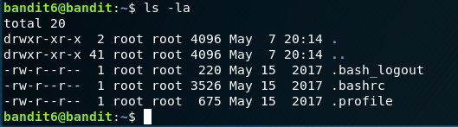

I then used the same process as last round



Then use cat for the file path above:



Success! Found the password for the level7

HKBPTKQnIay4Fw76bEy8PVxKEDQRKTzs

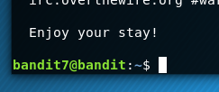 Success!